Project B.A.T. System Design Document

Last Revised: 5 May 2022

Kevin Green (k_green5@u.pacific.edu)

Project Wiki Page:

https://github.com/comp195/senior-project-spring-2022-blueprint-automation-tool-1/wiki

# Table of Contents

Table of Contents 2

Introduction 4

System Architecture 4

Software Modules 5

Settings Handler 5

Building Handler 5

Game Automation Handler 5

Color Handler 6

Keyboard Handler 6

Window Handler 6

C-Structure Python Redefinitions 7

Place Parser 7

User Interfaces 7

Main App 7

Hardware, Software, and System Requirements 8

Hardware and System Requirements 8

Software Requirements 8

External Interfaces 9

pywin32 Python Library 9

Minecraft Java Edition 9

WorldEdit 10

Software Design 11

Class Diagram 11

Class Specifications 12

User Interface 12

Software Modules 13

Interaction Diagrams 16

Starting the Program 16

Updating Configurations 16

Building A Saved Place 17

Stopping the Program 17

Design Considerations 18

Modularity 18

User Simplicity 18

Automation Speed and Accuracy 18

User Interface Designs 20

Home Screen 20

Dark Mode Variant 20

Configuration Screen 21

Dark Mode Variant 21

Glossary of Terms 22

References 23

# Introduction

As a result of the creative possibilities in the game Minecraft, players have taken on different types of projects to challenge their skills. One popular form of challenge that players taken on is the recreation of places that exist in the real world to scale. In the past, groups have taken on projects such as recreating monuments, theme parks, or entire cities.

However, the most tedious part of this challenge is the planning phase, where players must calculate measurements for the projects to create blueprints of the places they are trying to build. This process can become both time-consuming and challenging to execute, leaving room for players to easily become burnt out or frustrated with mistakes.

Project B.A.T., short for Blueprint Automation Tool, attempts to solve this problem by taking layouts that users draw out with Google Earth Pro and then draws those layouts to scale inside of a loaded Minecraft world. The application takes .kml and .kmz files saved by Google Earth Pro as “places” and uses them to create a 2D layout that players can later use to complete the actual building with their creativity. The project also makes use of reference coordinates and map projection algorithms to handle distortions to the map due to converting places from a ball earth to a perfectly flat Minecraft world. The project also supports multiple blocks and color detection to allow users to organize their layouts.

# System Architecture

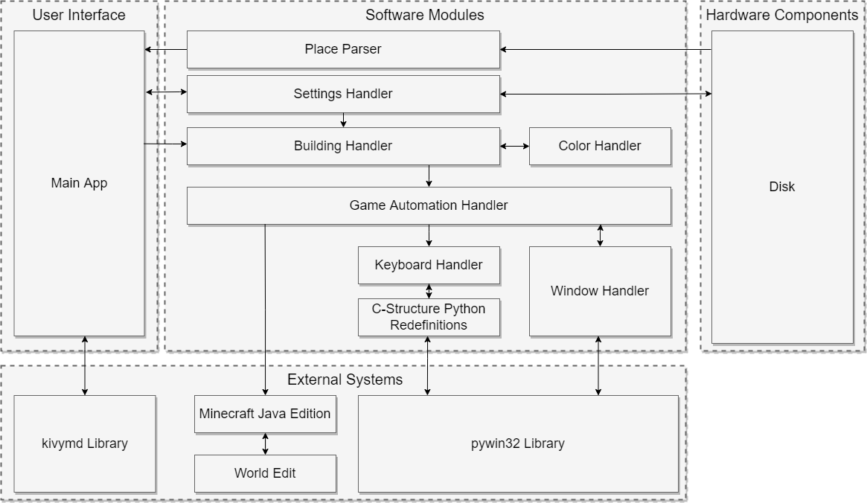

## 

## Software Modules

### Settings Handler

The settings handler is the module that takes care of updating and saving settings for the program. While the settings handler allows for changing settings in the program, the game automation handler will call to it to get certain settings that it needs that will affect calculations for map projections, scaling, keyboard input timing, and what commands are available for it to use. The settings handler will also keep track of the last loaded reference point and saved places so that a user can pick up where they left off if they need to take a break in-between use of the program.

### Building Handler

The building handler module is what ties most of the other software modules together to create a functioning application. Being the main interface with the home screen of the application, this module oversees telling the places parser module what file to read. It then takes the information given to it by the parser and the settings handler and completes the calculations to convert the geographical coordinates to the coordinate system that Minecraft uses. Once this is figured out, it creates the necessary commands to recreate the place. The building handler then takes advantage of the keyboard and window handlers to switch to the Minecraft window and execute the commands that it came up with. Afterward, the handler switches back to the blueprint tool’s user interface for further user interaction.

### Game Automation Handler

The game automation handler ties the generic Windows automation into specifically made actions for Minecraft. This includes commonly used actions such as World Edit commands, teleporting around the world, placing individual blocks, detecting game versions, and switching to the game. The game automation handler is primarily used by the building handler to make the automation of Minecraft simpler to implement.

### Color Handler

The color handler takes the color found for parsed places and attempts to find the closest matching dye color that exists in the game. This allows for colors to be automatically matched to those that users use when creating places inside of Google Earth Pro. This both simplifies the steps that a user needs to make to create a blueprint while also providing greater organization for their builds.

### Keyboard Handler

The keyboard handler oversees keyboard inputs to Windows to automate the interaction with Minecraft once it is set as the primary screen. Multiple keyboard inputs are needed to complete different interactions such as opening the game’s text chat, entering and verifying the commands for World Edit, and teleporting the player around the map. To minimize mistakes, the keyboard handler can implement self-checking to make sure that anything that any text that is inputted into a chat box matches what should have been typed. This should ensure that there are not any mistakes in commands that are given to the game, to avoid unexpected results.

### Window Handler

The window handler oversees switching back and forth between the open Minecraft client and the program window during the game automation. This handler needs to be able to successfully find and switch to the Minecraft window so that the program can input the right commands to recreate the places in Minecraft. After automation is complete, the module should be able to switch back to the blueprint automation tool so that the user can move onto a new saved place or tweak settings if necessary.

### C-Structure Python Redefinitions

This module handles the translation of input structures from the C-structures of the win32API to python classes that automation can handle. This allows for python code to make API calls to simulate keyboard presses into the Windows operating system.

### Place Parser

The Place parser is the module that oversees reading in the places from Google Earth Pro and finding the relevant information that is necessary to convert it into Minecraft blocks. This involves reading in the .kml and .kmz files that are the actual files that are created when a place is saved in Google Earth Pro. Then the parser reads through the file to find any relevant information related to the name of the place, the shape of the place, and the geographical coordinates that are saved within the files.

## User Interfaces

### Main App

The main app module is the main user interface that users of the blueprint automation tool will use. On this screen, users will choose the .kml and .kmz file that they want to have built, the reference point that the build should be centered around, and the block that they want the build to be made from. There will also be a button that will allow the user to start the automation, and to cancel it mid-way if something unwanted occurs as a failsafe.

The main app also contains a hidden configuration screen where the user will primarily make changes to how the program will perform when executing the automation steps. From this screen, the user makes changes to the scale of the layouts built, and the default height level that blueprints should be built on, and the block that the layouts will be built with.

# Hardware, Software, and System Requirements

## Hardware and System Requirements

Systems that plan to run the Blueprint Automation Tool should meet the minimum requirements to run Minecraft as listed by Mojang on their website. Depending on the size of the blueprint that the user is building, requirements will need to be higher than these listed requirements to experience improved performance in-game while the layouts of the places are being built.

|  |  |
| --- | --- |
| **Hardware** | **Minimum Requirement** |
| CPU | Intel Core i3-3210 3.2 GHz  AMD A8-7600 APU 3.1 GHz |
| GPU | *Integrated Graphics:*  Intel HD Graphics 4000 (Ivy Bridge)  AMD Radeon R5 series (Kaveri line)  *Discrete GPU:*  NVIDIA GeForce 400 Series  AMD Radeon HD 7000 series |
| RAM | 4 GB |
| Disk Space | 1 GB |
| Internet | Internet is required for the initial installation of the required software. Afterward, offline use of the tool is possible if the user is not connecting to an online multiplayer server. |
| OS | Windows 10 or Windows 11 |

## 

## Software Requirements

|  |  |
| --- | --- |
| **Software** | **Minimum Version** |
| Google Earth Pro | Latest available version |
| Minecraft Java Edition | Version 1.12.0 or newer |
| WorldEdit | Version 6.1.8 (for Minecraft 1.12) or newer |
| Java | Version 8 or newer |

*Note: Java 8 will automatically be installed for Minecraft versions 1.12 and newer when the game is installed onto the system. Multiplayer servers will need Java 8 to be manually installed on the host server to run.*

# External Interfaces

## pywin32 Python Library

The pywin32 library for Python is a series of modules that allow access to Windows APIs in python. In this project, this library is used extensively to allow keyboard and window automation to automate the process of building the scaled blueprints within the Minecraft environment.

More information and documentation for pywin32 are available through their online help file found at https://mhammond.github.io/pywin32/.

**kivymd Python Library**

The kivymd library for Python is an API that allows for the creation of user interfaces that follow Google’s Material Design standards. This library is used in this project in order to create a clean interface for the program’s front-end.

More information and documentation for kivymd are available through their GitHub repository at https://github.com/kivymd/KivyMD.

## Minecraft Java Edition

Minecraft is a popular video game where a player has a nearly infinite world to explore and build in. Java Edition is the original version of the game that is specific to desktop computers. This project is focusing on the creative version of the game, where players have infinite resources to build anything they like. Project B.A.T. takes advantage of these gameplay features to quickly create to-scale layouts of real-life locations.

More information and documentation about Minecraft, including gameplay mechanics, tutorials, changelogs, and available commands can be found in the community ran wiki for the game at https://minecraft.fandom.com/wiki/Minecraft_Wiki.

## WorldEdit

WorldEdit is a plugin and mod to the base vanilla version of Minecraft that allows players to quickly build large structures in-game without having to place each block individually using commands that can be entered through the text chat. WorldEdit is being used in this project to quickly create the layouts of places without having to manually set each block using vanilla commands.

More information and documentation for WorldEdit and its available commands can be found at its website at https://worldedit.enginehub.org/en/latest/.

# Software Design

## Class Diagram

## Class Specifications

### User Interface

### Software Modules

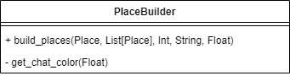

## Interaction Diagrams

### Starting the Program

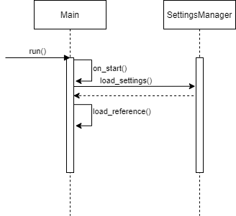

### Updating Configurations

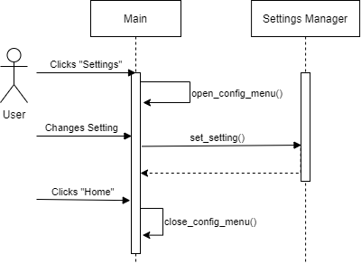

### Building A Saved Place

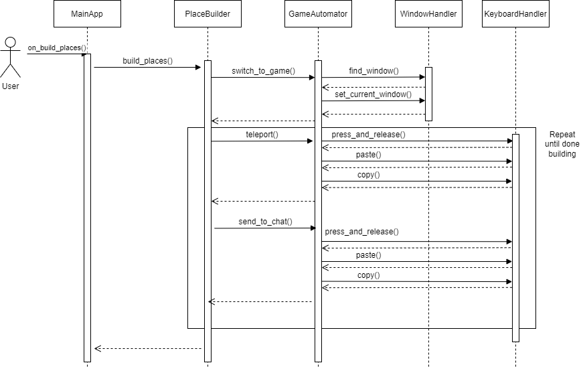

### Stopping the Program

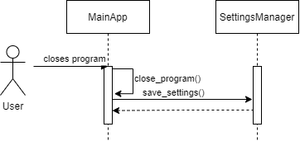

## Design Considerations

### Modularity

Classes for this project have been designed in a way that each class handles one specific area of the automation process. For example, the only job of the WindowHandler class is to handle window navigation on the screen, which involves bringing windows into focus. Another example is that the KeyboardHandler class is solely responsible for keyboard inputs to the operating system. Designing the project in this manner allows for easier debugging when something in the project behaves inconsistently or incorrectly, since the location of the code where the bug could be should theoretically only exist in one place. Additionally, the design of these “modules” allows them to be easily swapped out later for better versions of the same functionality. This design also will allow for the modules to be reused in future projects relatively easy.

### User Simplicity

One of the main goals for Project B.A.T. is to be as simple for the user to use as possible, given that they have all the required software installed. Using only two screens with minimal user input required, the application should become more easily understandable while having enough features and capabilities to allow the tool to be faster than manually creating the layouts by hand.

### Automation Speed and Accuracy

If Project B.A.T. takes too long to successfully recreate layouts in saved places within Minecraft, it has no major advantage over just manually building the layouts by hand. Therefore, automation classes were designed to take advantage of more low-level libraries for sending calls to the API to avoid the overhead that can be caused by other automation libraries that already exist for Python.

However, if the automation is not also accurate, then disastrous results could ensue. This accuracy problem is also a major consideration in why the creation of custom automation handlers of keyboards and window management is necessary. These custom modules allow for more controllable error detection and fail-safe checking that will allow for safer use of the project without major risks that could arise due to any number of system and user variables that cannot always be accounted for.

# User Interface Designs

## Home Screen

### Dark Mode Variant

## 

## Configuration Screen

### Dark Mode Variant

# Glossary of Terms

**Plugin:**

An additional extension added to a Minecraft that is installed onto a dedicated server. These extensions do not alter any gameplay mechanics themselves but only add onto existing ones.

**Mod:**

(Short for modification) Third-party changes or extensions of the original gameplay mechanics which can be installed onto single-player or multiplayer versions of the game.

**Vanilla:**

Refers to a video game that is in its original state. No mods or plugins have been installed to change or extend gameplay mechanics.

**Block:**

The basic unit of structure in Minecraft. Blocks make up the entire world, each block being equivalent to exactly one meter in the real world.

**Text Chat:**

The main form of communication between Minecraft players in the same world. This text box allows players to enter messages that will be shown to the other players in the world. If cheats are enabled on a server or single-player world, players can enter commands that will result in various effects taking place towards other players or the world.

**Place:**

A saved location from Google Earth Pro that is saved as a .kml or .kmz file that is located locally on a user’s computer.

# References

BuildTheEarth, “Build The Earth,” *BuildTheEarth*, 2022. [Online]. Available: https://buildtheearth.net/. [Accessed: 19-Jan-2022].

EngineHub, “WorldEdit 7.2 Documentation,” *WorldEdit Documentation*, 2022. [Online]. Available: https://worldedit.enginehub.org/en/latest/. [Accessed: 02-Feb-2022].

EngineHub, “WorldEdit,” *EngineHub*. [Online]. Available: https://enginehub.org/worldedit/. [Accessed: 19-Jan-2022].

Google, “Earth versions – google earth,” *Google*, 2022. [Online]. Available: https://www.google.com/earth/versions/. [Accessed: 19-Jan-2022].

H. Goebel, G. Bajo, D. Vierra, D. Cortesi, and M. Zibricky, “pyinstaller,” *PyPI*, 2022. [Online]. Available: https://pypi.org/project/pyinstaller/. [Accessed: 19-Jan-2022].

ImagineFun, “Imagine fun,” *Imagine Fun*, 2021. [Online]. Available: https://imagineeringfun.net/. [Accessed: 19-Jan-2022].

KivyMD, “KivyMD”, *GitHub*, 2022. [Online]. Available: https://github.com/kivymd/KivyMD. [Accessed: 08-Apr-2022].

M. Hammond, “Python for Win32 Extensions Help,” *GitHub.io*, 2022. [Online]. Available: https://mhammond.github.io/pywin32/. [Accessed: 02-Feb-2022].

M. Hammond, “pywin32,” *PyPI*, 2022. [Online]. Available: https://pypi.org/project/pywin32/. [Accessed: 19-Jan-2022].

MCParks, *MCParks*, 2022. [Online]. Available: https://mcparks.us/. [Accessed: 19-Feb-2022].

“Minecraft Wiki,” *Minecraft Wiki – The Ultimate Resource for Minecraft*, 2022. [Online]. Available: https://minecraft.fandom.com/wiki/Minecraft_Wiki. [Accessed: 02-Feb-2022].

Mojang, “Get minecraft,” *Minecraft.net*, 21-Sep-2021. [Online]. Available: https://www.minecraft.net/en-us/get-minecraft. [Accessed: 19-Jan-2022].

Mojang, “Minecraft official site,” *Minecraft.net*, 10-Nov-2021. [Online]. Available: https://www.minecraft.net/en-us. [Accessed: 19-Jan-2022].

Python Software Foundation, “Welcome to Python.org,” *Python.org*, 2022. [Online]. Available: https://www.python.org/. [Accessed: 19-Jan-2022].